**Mingjia Yao, 905302291**

**STATS 232C, Homework 4**

**Value and policy table of goal A, with original reward**

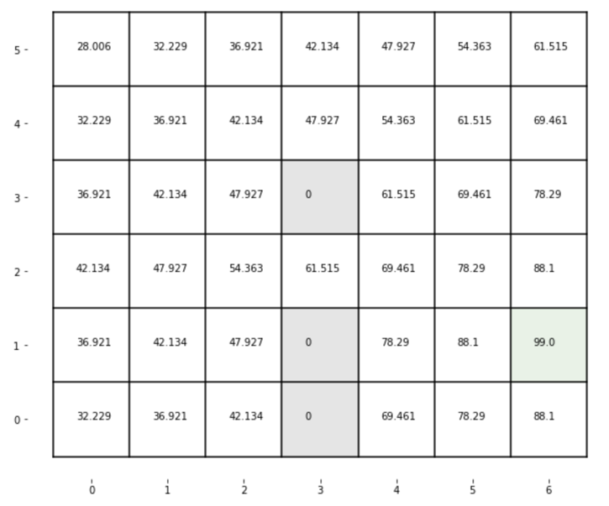

**Value and policy table of goal A, with new reward**

In the policy table of the new reward table, the policy of state (0,5) changes to avoid the ambiguity with goal C, and the policy of state (5,4), (5,5) change to avoid the ambiguity with goal B.

**Value and policy table of goal B, with original reward**

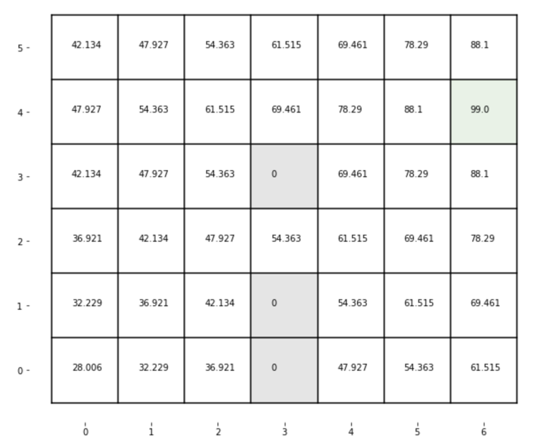

**Value and policy table of goal B, with new reward**

In the policy table of the new reward table, the policy of state (0,5) changes to avoid the ambiguity with goal C, and the policy of state (5,0), (5,1) change to avoid the ambiguity with goal A.

**Value and policy table of goal C, with original reward**

**Value and policy table of goal C, with new reward**

In the policy table of the new reward table, the policy of state (6,3) changes to avoid the ambiguity with goal B, and the policy of state (6,0) change to avoid the ambiguity with goal A.